Sreeti Ravi

Google Cloud Platform Quest

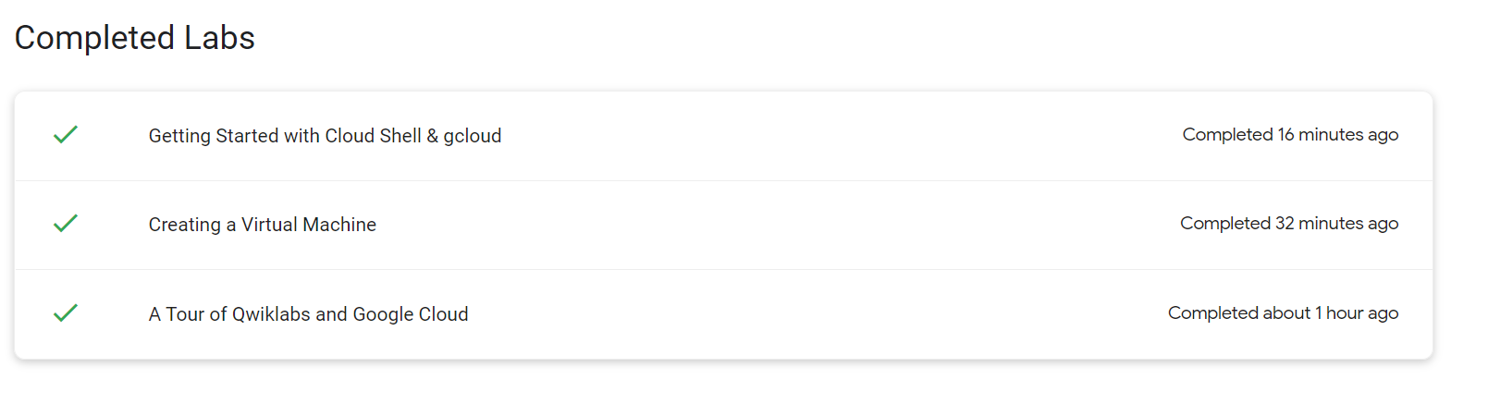

I was not sure what page I was supposed to screenshot. I found a page in my profile that tells me which labs I finished, so that is what I screenshotted.

I have never use QwikLabs or the Google Cloud platform before, but I use the Azure platform at work and they seem to have similar user interfaces. I thought that the quests were a good introduction to the Google Cloud platform. I thought it was easy to follow along and they did a good job of explaining everything. I did not have any challenges while doing the exercises.